Issues encountered integrating the Modular Complex System

There were many issues implementing the System, one of the main ones was creating the chromosomes and the population. I was unable to figure out how to create the population while also adding the to the population for a week. I eventually figured out how to appropriately implement pointer to allow the chromosomes class and the population class to interact with each other. The next big hurdle was the fitness function itself for the first week I could not think of a way create a function to show off the population being created. I eventually came up with the idea to show an individual moving on screen. However, I still needed to implement crossover and mutation it took a while to finally figure the implementation of all the functions and being able to use them all together. I feel I now have a better understanding of pointers and templating thanks to these issues I encountered.

Performance of the System

The Genetic Algorithm preforms relatively smooth although if I had more time I believe I could improve the speed of it however it still performs at an acceptable pace the Test application itself requires a random set of direction and uses thous to travers a randomly generated maze. The fitness function is used to tell it that it needs to move closer to the end gaol.

Required Changes for the system to function as intended

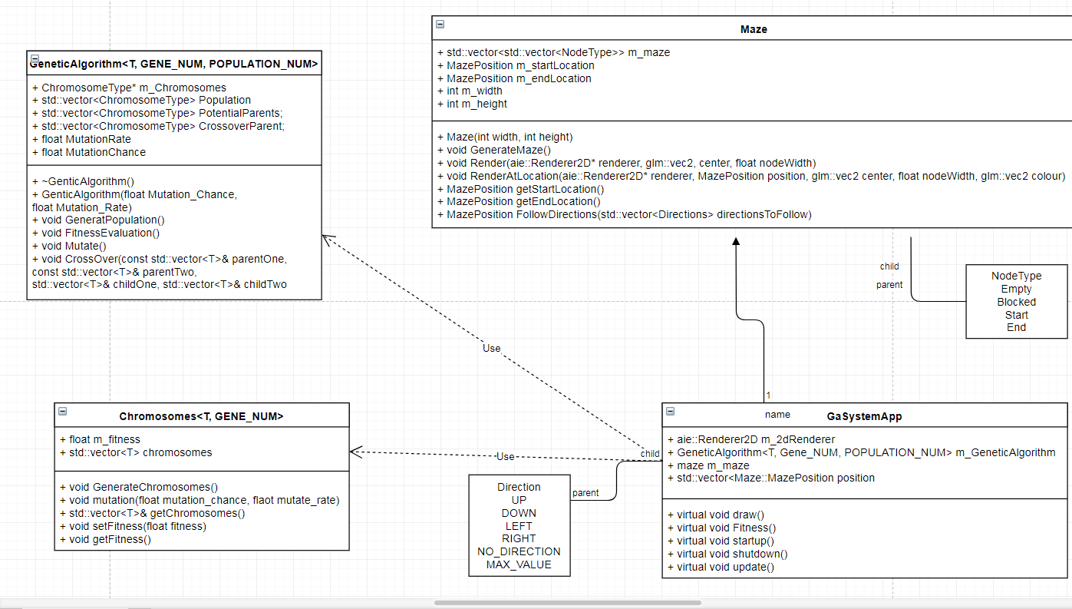There were no Required changes for it to function properly, the was a change of the presentation of the test application. My original idea for the test application was to make the maze in the console however implementing a 2D maze was not a difficult as I initially expected it to be.